My motto: “Educate. Empower. Excel."  — Advancing minds with purpose, integrity, and impact.   SKILLS with passion  - Higher Education Leadership & Governance  - Economic Policy & Business Education  - Strategy Framework Development  - Research Supervision & Dissertation Guidance  - Curriculum Design & Academic Quality Assurance  - Policy writing, Formulation and implementation  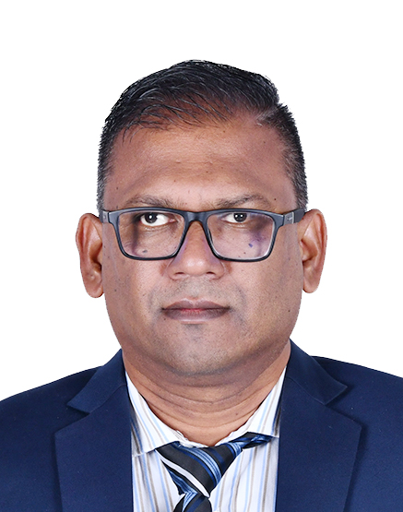  Dr Rakesh Ramchurn  Jagdish Parsad Street  Plaine Magnien  Mauritius  DOB: 09.12.1974  ID: R0912744700071  Status: Married  +230 57128327 / +230 6373013  rakeshramchurn@yahoo.co.uk  SUMMARY  Distinguished academic and researcher with over 25 years of cross-sector experience in teaching, curriculum development, academic leadership, and applied research across Economics, Business, Accounting, Educational Leadership, and Knowledge Management. Holds a PhD in Management and multiple advanced degrees, with a strong publication record and a proven track record in postgraduate supervision, institutional assessment, and higher education governance. Currently pursuing postdoctoral research in Knowledge Management, with a focus on innovation and performance in public sector organizations. Recognized for academic excellence, strategic insight, and a sustained commitment to educational advancement, policy impact, and capacity building at both secondary and tertiary levels.  - )  kjkjkjjkd
   EXPERIENCE with Pride, Dignity, Honesty & Ethics
  
  Lecturer – Research Methods, Teacher Leadership & Psycho-Pedagogy (Part-Time) |Open University of Mauritius
  Jan 2021 - Current
  - Deliver postgraduate modules in education leadership and pedagogy.
  - Supervise M.Ed. research projects and dissertations.
  - Contribute to academic board discussions and programme evaluations.
  Lecturer / External Examiner / MBA Supervisor (Part-Time) |University of Technology, Mauritius
  Jan 2007 - Current
  - Lectured on Knowledge Management, HRM Trends, and Management in International Perspective.
  - External examiner for postgraduate business modules and dissertation panels.
  - Supervised over 20 MBA dissertations across strategic and operational management themes.
  Visiting Lecturer – Research Methods at Amity University
  Jan 2018 - Dec 2018
  - Lecturer in Management and Research Methods (Distance & Campus-based)
  Lecturer in Management (Distance & Campus-based) |EIILM University, India
  Jan 2008 - Jan 2012
  - Lecturer in Management (Distance & Campus-based)
  
  Educator – Economics, Business Studies at Rose Belle High School (Jan 1994 - Jan 2003)
  - Facilitated economic literacy and analytical thinking in students at secondary level.
  - Supported school leadership in subject coordination and performance analysis.
  Educator – State Colleges as Economics Educator
  (Jan 2003 – Now)
  - Facilitated economic literacy and analytical thinking in students at secondary level.
  - Supported school leadership in subject coordination and performance analysis.
  - Head of Economics Department
  
  CURRENT ACADEMIC ACTIVITIES
  - Postdoctoral Research in Knowledge Management: University of Utara Malaysia
  - Focus: Knowledge Management Systems in Civil Service Organisations
  - Engaging in collaborative research, knowledge transfer strategies, and publications
   AWARDS with Pride
  - Medal winner BA (Hons) |Economics with Management Studies Napier University, Scotland
  - Distinction in MPhil University of Technology,
  - Distinction in MBA EIILM University, India
  - Merit in MA Educational Leadership Middlesex University
  - Good Standing in Ph.D. in Management University of Malaysia Terengganu
   EDUCATION with Outstanding Blessings
  - Post-Doctoral in Management-UUM Malaysia
  - PhD Management - University of Malaysia Terengganu with Good Standing Jan 2024
  - MA Educational Leadership - Middlesex University
  With Merit Jan 2021
  - PGDELM Leadership & Management - Mauritius Institute of Education Dec 2019
  - MPhil Management - University of Technology, Mauritius with outstanding performance June 2014
  - MBA Accounting & Finance - EIILM University, India
  With Distinction Jan 2010
  - MSc E-Business - University of Mauritius Jan 2004
  - BA (Hons)|Economics with Management Studies
  Napier University, Scotland Medal winner Jan 2001
  - Advanced Diploma Business Administration – UK
  HOBBIES AND INTERESTS with joy and delight
  - Educational research
  - Policy development and formulation
  - Management psychology
  - Mentoring and youth coaching
  - Fitness and wellness
  - Community development
  - Social engagement
   PUBLICATIONS of International Standards
  - Ramchurn, R. (2024). A comprehensive framework for strategic knowledge management in civil service organisations of Mauritius. Multiscience Journal. DOI: 10.31893/multiscience.2024203
  - Ramchurn, R. (2024). Knowledge management technologies in Mauritius civil service: Empirical findings. Multiscience Journal. DOI: 10.31893/multiscience.2024232
  - Ramchurn, R. (Co-author). E-learning and barriers to implementation in Mauritius. In Issues of ICT in Education, Kanishka Publishers, New Delhi.
  Ramchurn, R. (2023). Knowledge management in Mauritian civil service organisations: an empirical analysis. Russian law Journal
  Knowledge Management and Promises: Global Journal of Management and Business Research January 2010
  - Education and Economic Growth in Mauritius: A Multivariate Analysis – Empirical Economics

